Week 7 Bellwork Sheet – October 2nd – October 6th Name: __________________Period: ________
Monday | Week #7 Vocab – DOI #1
Tuesday | 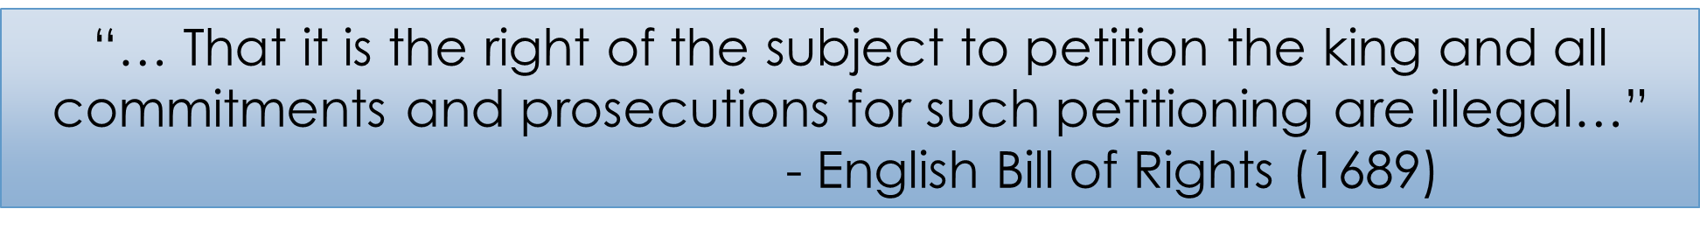  Which of the following best explains this sentence?  - If people, complain to the king they will be punished  - Only British citizens can complain to the king and Parliament  - People have the right to complain to the king without fear of being punished  - People need to send complaints to the king, but the complaints are limited to certain topics
Wednesday
Thursday | 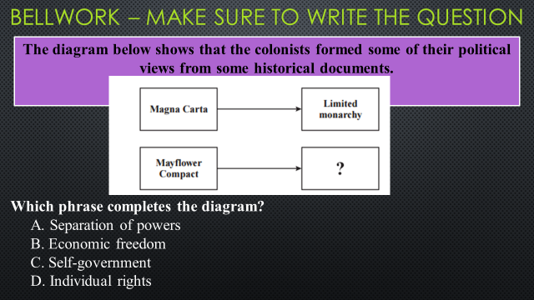
Friday | Enlightenment Quiz Day  - Silent Study for 5 minutes prior to test

