Week 6 Bellwork Sheet – September 25th – September 29th Name: __________________Period: ________
Monday | Week #6 Vocab – Enlightenment #3
Tuesday | - Work on completing the document analysis from Friday!  - The documents are on the desks – if you don’t have one grab one from a nearby empty desk  - Should be in your test section
Wednesday | - The passage below comes from the Declaration of Independence.  According to this passage, what is the principle role of government?  - To promote greater social equality  - To protect the natural rights of citizens  - To glorify the ruler in the eyes of the Creator  - To help individuals cooperate against the forces of nature
Thursday | - Use the diagram to answer the question  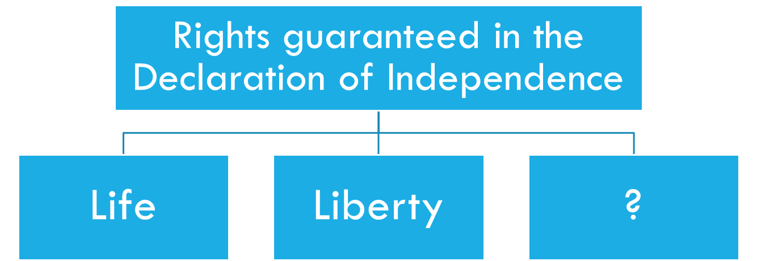  Which of the following correctly completes the diagram?  a. freedom of speech  b. freedom of religion  c. freedom to own property  d. pursuit of happiness
Friday | - Which colonial leader introduced the ideas of John Locke’s “Social Contract” theory into the Declaration of Independence  - John Hancock  - Thomas Paine  - James Madison  - Thomas Jefferson  - According to the Declaration of Independence, what was an “unalienable right” that all governments should protect?  - The right to social equality  - The right to personal liberty  - The right to religious equality  - The right to elect government officials

