Week 3 Bellwork Sheet – August 28th –September 1st Name: __________________ Period: ________
Monday | Tell Me Tuesday – What is the difference between a responsibility and an obligation as they relate to citizenship? Give an example of each
Tuesday | Week 3 Vocab List
Wednesday | - What right do citizens have?  - Attending public schools  - Owning property  - Holding a job  - Voting  - A citizen received the notification below in the mail.  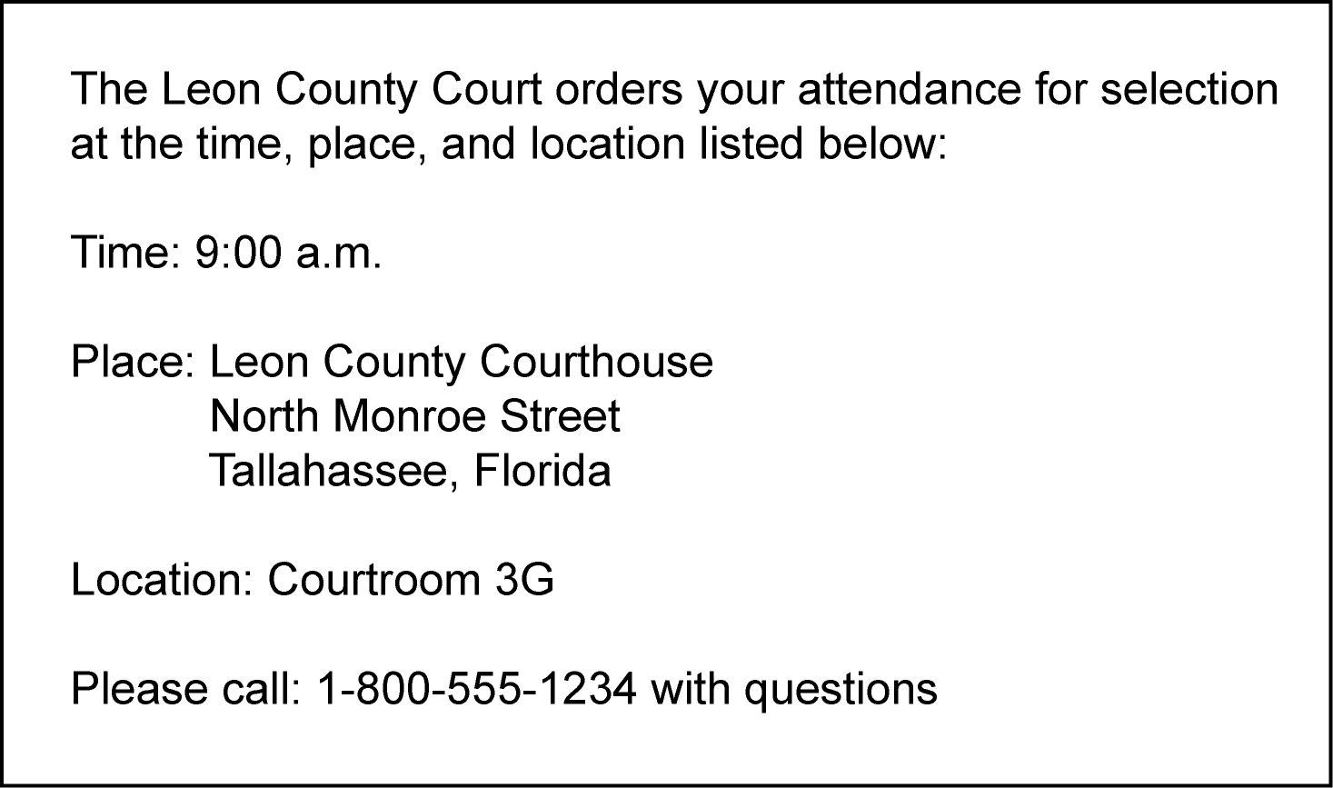  What civic responsibility does this notification represent?  - Getting a driver’s license  - appearing for jury duty  - paying income tax  - registering to vote
Thursday | - What right do citizens have?  - Attending public schools  - Owning property  - Holding a job  - Voting  - Which type of service project would help promote the common good?  - Planning a neighborhood recycling program  - Participating in a neighborhood party  - Completing homework on time  - Visiting public libraries
Friday | - Which are examples of Natural Rights?  - the right to life, liberty, property, and the freedom to find happiness  - the right to life, liberty, and the pursuit of happiness  - the right to life, freedom, and the right to own property  - the right to liberty, pursuit of happiness, and to vote  