Week 2 Bellwork Sheet – August 21st – 25th Name: __________________ Period: ________
Monday | Week 2 Vocab List
Tuesday | Tell Me Tuesday – What is the difference between a responsibility and an obligation as they relate to citizenship?
Wednesday | - Which type of service project would help promote the common good?  - Planning a neighborhood recycling program  - Participating in a neighborhood party  - Completing homework on time  - Visiting public libraries  - Which example is NOT a responsibility of citizenship?  - Volunteering in the community  - Attending civic meetings  - Voting in elections  - Paying taxes
Thursday | - What right do citizens have?  - Attending public schools  - Owning property  - Holding a job  - Voting  - A citizen received the notification below in the mail.  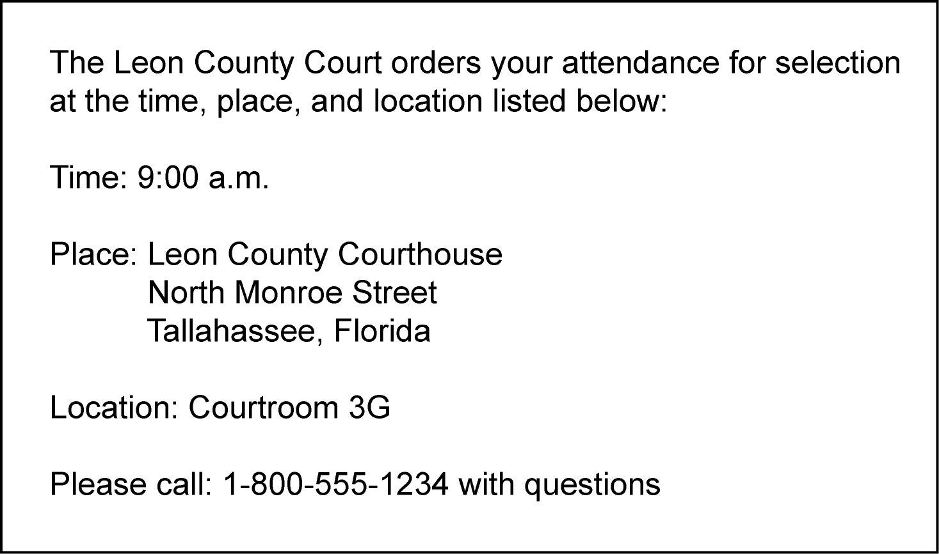  What civic responsibility does this notification represent?  - Getting a driver’s license  - appearing for jury duty  - paying income tax  - registering to vote  - Which type of service project would help promote the common good?  - Planning a neighborhood recycling program  - Participating in a neighborhood party  - Completing homework on time  - Visiting public libraries
Friday | - Which option provides a citizen with the opportunity to directly impact local government?  - Testifying before Congress  - Participating in a community service project  - Voting for president  - Speaking at a city council meeting  - Which option provides a citizen with the opportunity to impact state government?  - Testifying before Congress  - Conducting a service project  - Voting for governor  - Joining an interest group  - Which option provides a citizen with the opportunity to impact the federal government?  - Testifying before Congress  - Conducting a service project  - Voting for governor  - Joining an interest group

