Week 1 Bellwork Sheet – August 14th – 18th Name: __________________ Period: ________
Monday | Week 1 Vocab List
Tuesday | Tell Me Tuesday – In your own words what does a good citizen do? What are their characteristics?
Wednesday | - Which is a requirement for a person to become a naturalized U.S. citizen?  - Marrying a U.S. citizen and having a child with that person.  - Being a legal resident of the U.S. for at least five years.  - Gaining employment in the U.S. for at least five years.  - Reaching age eighteen while living in the U.S. capital.  - The events below describe the use of a government document.  ---------------------------  Laura was born in France and lived in France until she immigrated to the U.S. at age 21. At age 25, Laura visited Morocco on vacation.  ---------------------------  Why did Laura use a U.S. passport to travel?  - Laura was a resident alien of the U.S.  - Laura was a resident national of the U.S.  - Laura was a U.S. citizen by the law of soil  - Laura was a U.S. citizen by the law of blood.
Thursday | - The passage below describes a court decision.  The Burlingame Treaty (1870) allowed the U.S. to deny citizenship to persons born in the U.S. whose parents were born outside the U.S. The U.S. Supreme Court granted writ of certiorari to a case challenging the constitutionality of the treaty.  How did the court apply the 14th Amendment to decide this case?  - To deny a native person citizenship rights does not support constitutional principles.  - A naturalized citizen possesses all the rights of a native citizen according to the Constitution.  - Persons born outside the U.S. are not permitted to pursue citizenship because they are unemployed.  - Persons born outside the U.S. are not permitted to pursue citizenship because they do not own property.  - Below is a table of the four most populated states in the United States  State % of Naturalized Citizens from State’s Immigrant Population  California 46%  Florida 49%  New York 52%  Texas 32%  How might these populations affect political campaigns?  - Candidates for governor will campaign for immigration reform in Texas.  - Candidates for president will campaign for immigration reform in Florida.  - Candidates for governor will campaign for naturalization reform in California.  - Candidates for president will campaign for naturalization reform in New York.
Friday | - The table below describes permanent resident status.  Year Number of Persons Obtaining Permanent Resident Status in the U.S.  2005 1,122,257  2007 1,052,415  2009 1,130,818  2011 1,062,040  Based on the table, what could be predicted about the impact of permanent residents on government?  - The number of persons seeking citizenship by law of soil would decline.  - The number of persons seeking citizenship by law of blood would increase.  - The number of persons seeking naturalization would be affected by elections for Congress.  - The number of persons seeking naturalization would be affected by elections for governor.  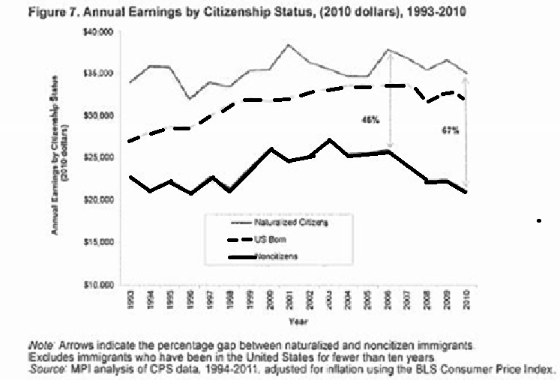  - Below is a graph about employment rates in the United States.  Which of the following long-term impacts on society may best explain what is reflected in the graph?  - higher income levels among U.S. residents  - higher poverty rates among U.S. residents  - higher education levels among U.S. citizens  - higher taxation rates among U.S. citizen

