SS.7.C.2.1 – What does it mean to be a citizen? How is citizenship obtained?
Notes Sheet
Image Analysis – Activity 1
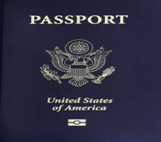 | What does the image represent?  How do you know?  What does this image have to do with U.S. citizenship?
What does the image represent?

How do you know?

What does this image have to do with U.S. citizenship?
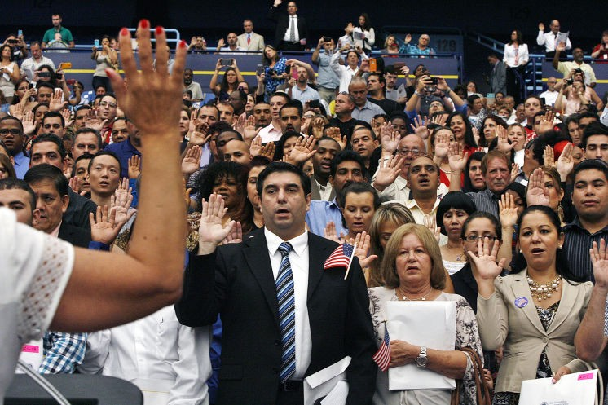 | What does the image represent?  How do you know?  What does this image have to do with U.S. citizenship?

Understanding Citizenship – Activity 2

14th Amendment, Section 1 | All persons born or naturalized in the United States, and subject to the jurisdiction thereof, are citizens of the United States and of the State wherein they reside. No State shall make or enforce any law which shall abridge [take away] the privileges or immunities of citizens of the United States; nor shall any State deprive any person of life, liberty, or property, without due process of law; nor deny to any person within its jurisdiction the equal protection of the laws.
From Kids Law | The 14th Amendment is a very important amendment that defines what it means to be a U.S. citizen and protects certain rights of the people. The Citizenship Clause gives individuals born in the United States – but especially at that time, African Americans – the right to citizenship. Before the 14th amendment, African Americans could not become citizens, and this limited the rights of those who were able to escape slavery and become free. This clause allows all people born in the United States to be U.S. citizens. Once you have American citizenship, it cannot be taken from you by Congress or other authorities, unless you lie to the government during the process to get U.S. citizenship. Otherwise, everyone who becomes an American citizen stays an American citizen, unless they give it up themselves.
Definition of citizenship
What is a citizen?

Citizenship: Just the Facts
Three Ways of Becoming a Citizen of the United States
Impact of the Naturalization Process Discussion
Naturalization Process
Using complete sentences, explain the naturalization process.

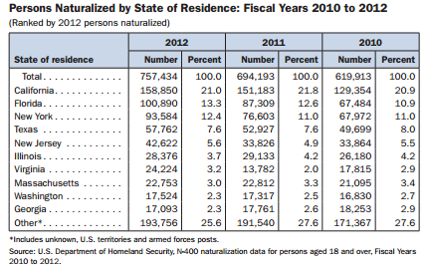
Naturalization – Chart Analysis
What information is being presented in this table? How do you know?

How would you summarize what you are seeing?

Where do naturalized citizens live?

What do you notice about Florida?

How might states be impacted by naturalized citizens?

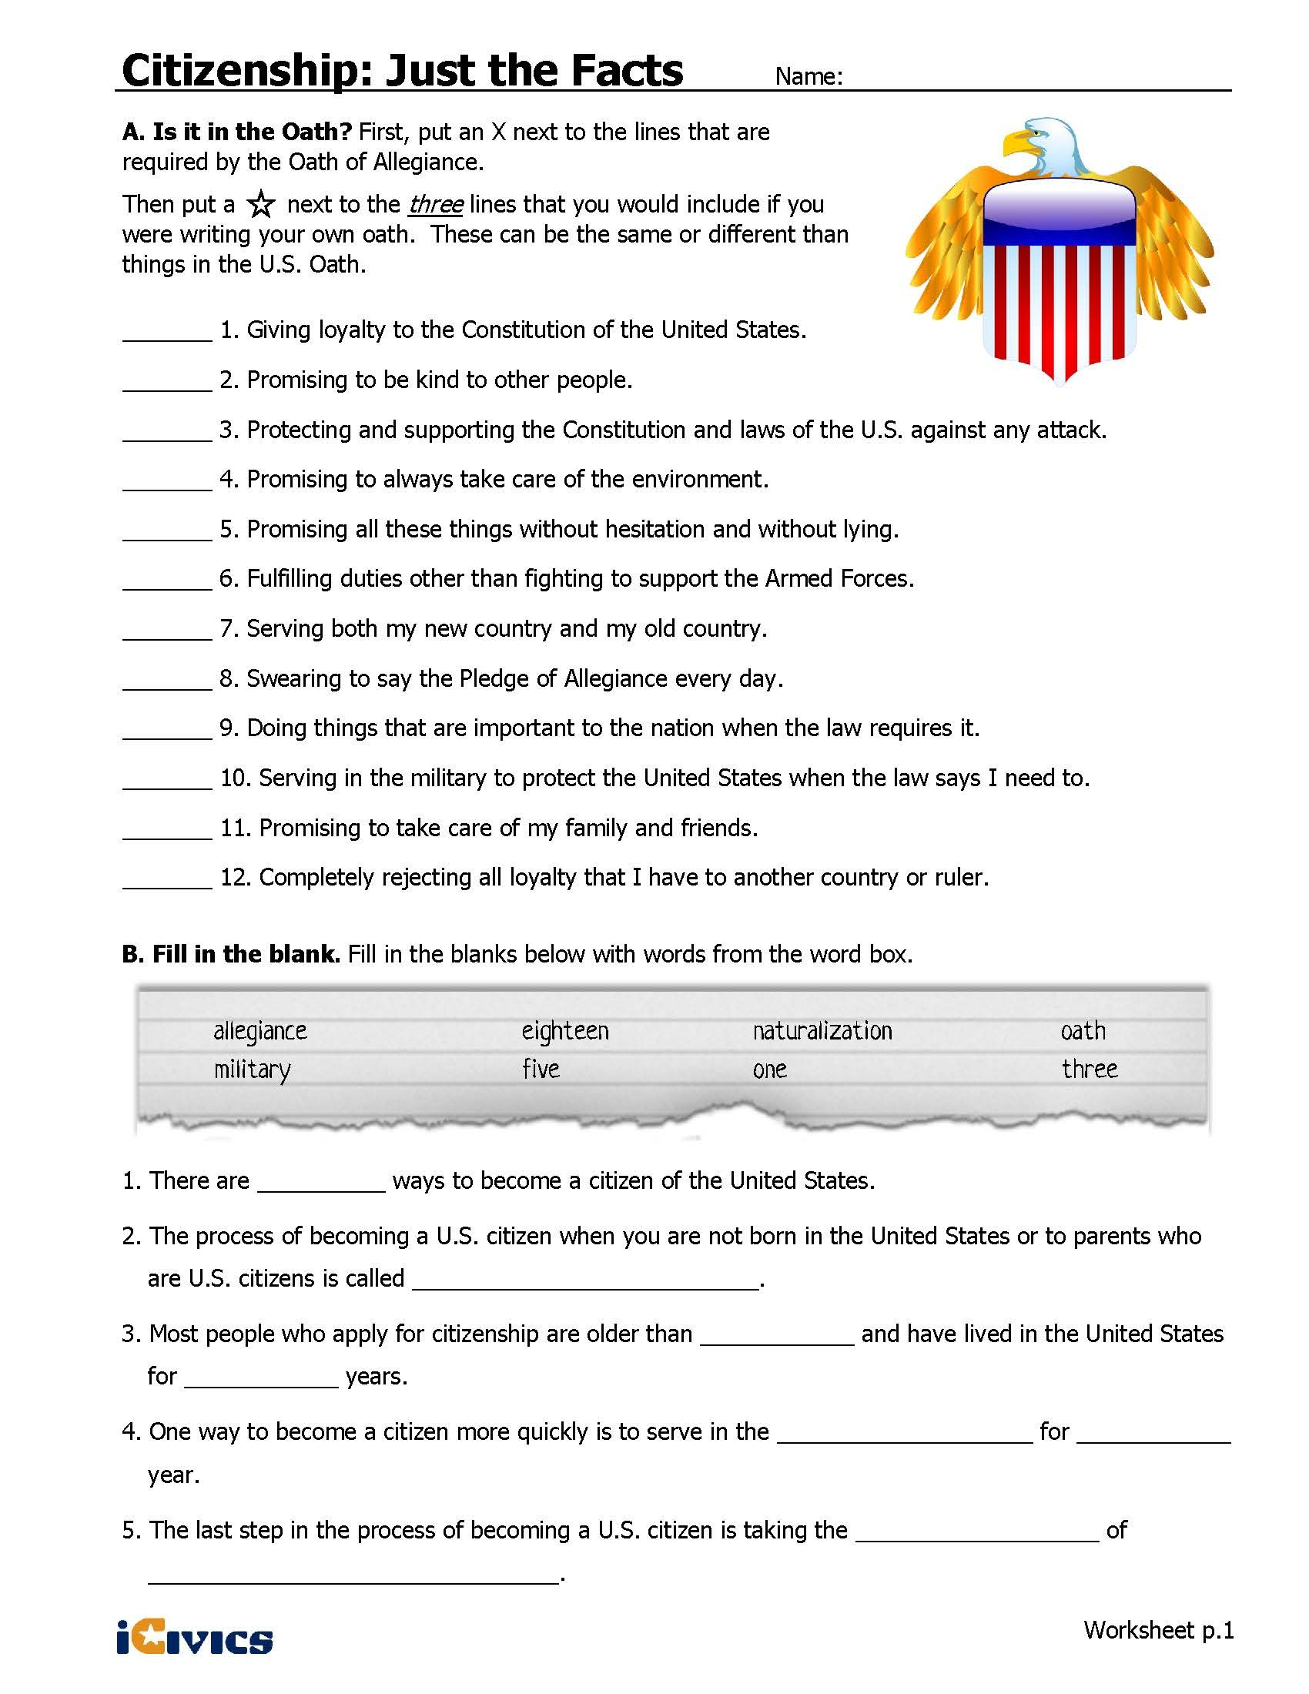

Video Viewing Guide
Naturalization Ceremony Video | Specific Evidence from the Video | Complete Sentence
Why might the President say this is one of his favorite things to do?
What is the significance of holding the ceremony on the 4th of July?
Who are some of the individuals he mentions in his remarks? Which of their stories interests you and why?
Notes from Class Discussion

Check for Understanding #1 – Quick Write

Check for Understanding #2

