Week 5 Bellwork Sheet – November 13th – November 17th Name: __________________Period: ________
Monday | 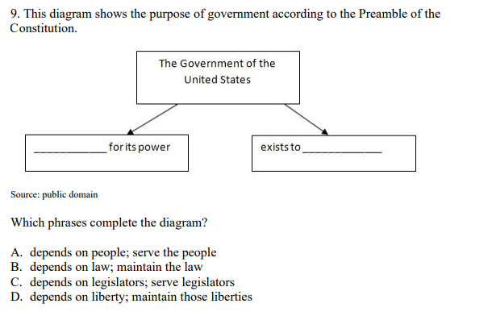
Tuesday | 1. One of the major weaknesses of the Articles of Confederation was that most of the power was given to:  - The legislative branch of the government  - The states  - The chief executive  - The Federal courts  2. Delegates to the Constitutional Convention of 1787 wrote a new constitution because  - the Revolutionary War was over  - the Articles of Confederation were about to expire  - they wanted to increase the power of the states  - they believed that a stronger central government was necessary
Wednesday | 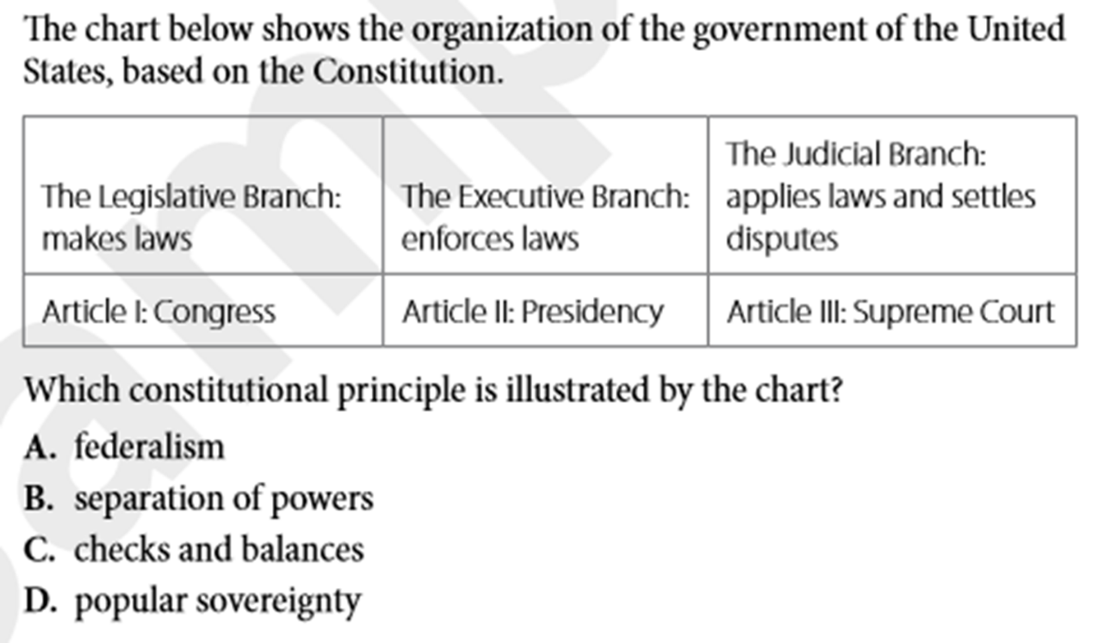
Thursday | How does the system of checks and balances reinforce separation of powers?  - By giving each branch of government powers to limit the other branches  - By dividing government duties among three branches  - By defining roles of each branch of government in three separate articles  - By dividing power between the national and state levels of government
Friday | Silent Study before Constitution part 1 quiz (5 mins)

