Week 3 Bellwork Sheet – October 30th – November 3rd Name: __________________Period: ________
Monday | Which of the following was a weakness of the Articles of Confederation?  A. The government did not have a separate judicial branch.  B. The states could not print their own currency.  C. The president was able to spend taxes freely.  D. The government had too much power over trade.
Tuesday | Why did the Second Continental Congress create a weak central government?  - To encourage more trade between states  - To preserve the powers of individual states  - To promote national security against foreign invasion  - To permit the taxation of citizens to pay the nations debts
Wednesday | What is the MOST LIKELY reason it was difficult to pass laws under the Articles of Confederation?  A. Passage required a unanimous vote of the 13 states  B. Passage required the votes of 9 of the 13 states  C. The government did not have a legislature?  D. Americans were content (happy) to follow British laws
Thursday | 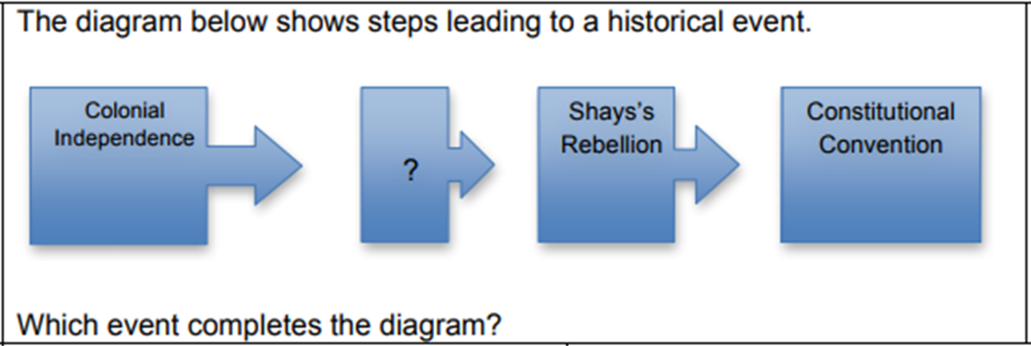  - Annapolis Convention  - Articles of Confederation  - Declaration of Independence  - Whiskey Rebellion
Friday | 1. Which of the following might have caused people to oppose the Articles of Confederation?  - Congress had the power to collect taxes  - Congress could not pay the soldiers who fought in the revolutionary war  - Congress controlled trade between the states  - Congress granted too much power to the executive branch  2. Which duty of citizenship is critical to support government services?  - Obeying the law  - Serving on a jury  - Serving in the military  - Paying taxes

