Week 1 Bellwork Sheet (Q2) – October 16th – October 20th Name: __________________ Period: _____
Monday | 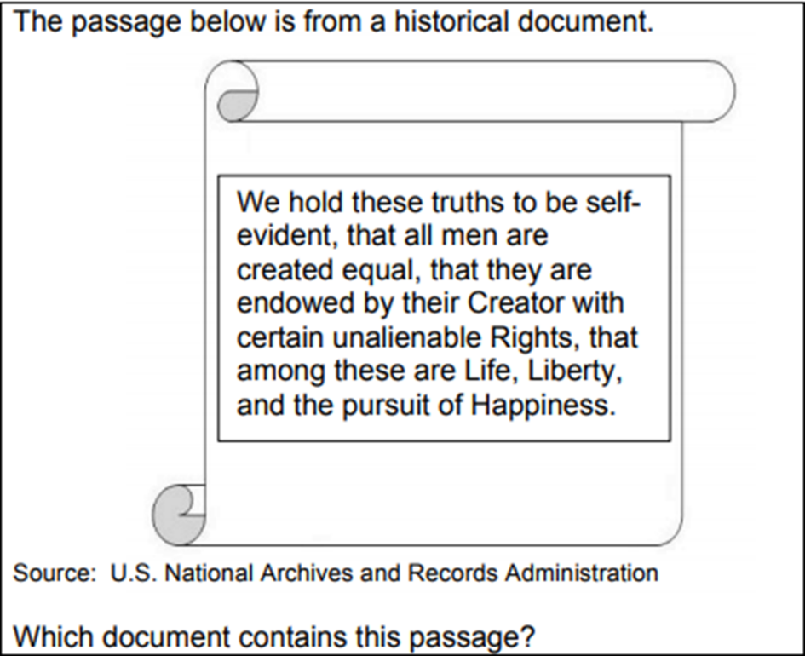  A. Declaration of Independence  B.Articles of Confederation  C.Constitution  D.English Bill of Rights
Tuesday | Which colonial concern led to the writing of the Declaration of Independence?  - The king failed to tax the colonists.  - The king required the colonists to elect a monarch.  - The king denied the colonists the right to petition  - The king denied the colonists representation in government.  Why was the French and Indian War a critical event in the relationship between American colonists and Great Britain?  - The war caused Britain to grant more powers to colonial legislatures  - The war prevented colonies from trading with Britain  - The war led Britain to increase taxes on the colonies  - The war resulted in a restriction on immigration in the colonies
Wednesday | 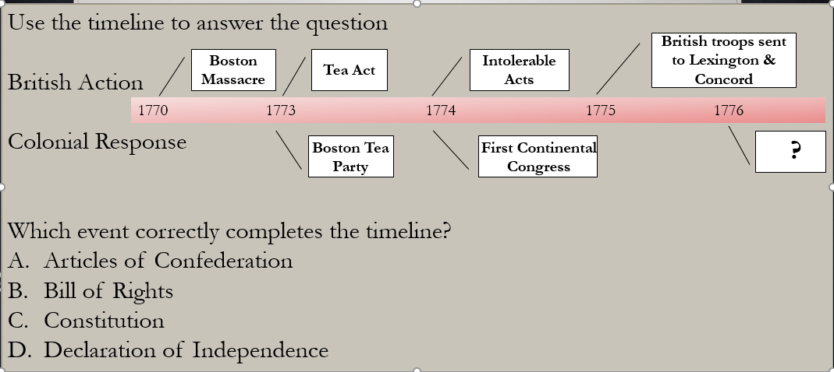
Thursday | Bellwork was to copy a part of the DOI to use for classwork later
Friday | Benchmark Practice Questions

