John Locke Name:

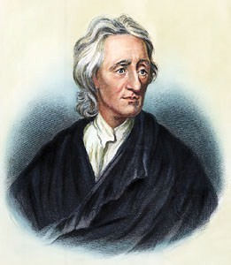
A Man with Many Hats
John Locke was born in England in 1632. Locke considered becoming a minister, started his career as a doctor, but ended up as a philosopher and political scientist. He had many interests and produced a number of writings that influenced future leaders. One of those leaders was Thomas Jefferson, who helped America gain independence from Britain nearly 150 years after Locke was born. Jefferson studied Locke’s
writings, and Locke’s ideas show up in our own Constitution.

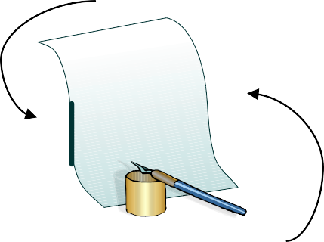
Experience

EXPOSURE to the World

Natural Rights
The Blank Slate
One of Locke’s books, called An Essay Concerning Human Understanding, took over 18 years to write! In it, he says that people are born with a mind like a tabula rasa, which means a blank slate or page. During life, that blank slate gets filled up with the things a person experiences with the five senses. He said people learn and develop differently because they are exposed to different things. The one thing people have in common is that they are human and share a human nature that is the same for all people everywhere.

People need: Life
Liberty Property
Locke imagined a set of natural rights that human beings share. These are the right to life, liberty, and property. Life refers to the fact that people want to live and will fight to survive. Liberty means that people want to be as free as possible to make their own decisions.
Property represents the fact that people want to own things that help them survive, such as land, food, and tools. Locke believed these rights aren’t given to people—people are born with them.

Why do we need a government?

A GOVERNMENT CAN:

Offer Protections Provide Services
Locke also wondered what life would be like if people didn’t have a government. In this state of nature there would be no rules, no one in charge, and no way for people to protect their natural rights. He believed the purpose of government is to end the state of nature and give people certain protections. Most importantly,
Locke believed governments should protect people’s natural rights.

Social Contract
Locke believed a government can only be legitimate, or valid, if it is based on a social contract with citizens. A contract is an agreement between people in which both sides agree to something in order to reach a shared goal. A social contract happens between a government and its people. The people agree to give up some freedoms if the government agrees to protect everyone’s rights. If the government fails to deliver, the people revolt—like the colonists did during the American Revolution.
The
People
The
Government

Influence Library Locke p.1

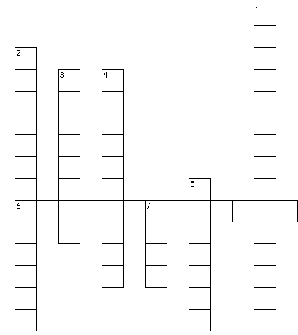
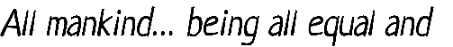
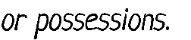
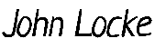
John Locke Name:
Vocabulary. Complete the crossword puzzle using terms you learned in this lesson.
Across
6. life, liberty, and property
Down
- agreement between a government and its people
- living without rules or a government
- things that you own: land, food, tools
- a blank page or slate
- freedom to make your own decisions
7. the natural right to live and survive

What if? What would life be like in the state of nature? Draw a scene and include at least three labels describing what is happening. To the right, explain how government keeps ONE of these things from happening.

In your scene, what is one thing a government can prevent?

How does a government prevent it?

Influence Library Locke p.2

Baron de Montesquieu Name:

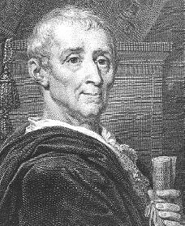
A Baron is Born
Charles Louis de Secondat was born in 1689 in the city of Bordeaux, France. At age 27, he became Baron de Montesquieu (MON-teh-skew) when he inherited his uncle’s fortune and title. Montesquieu was one of the great thinkers of the 17th and 18th centuries. He spent a lot of time thinking about how governments should be created and maintained. His ideas guided the Founding Fathers when they wrote the United States Constitution. Even today, Montesquieu’s thinking influences the way people think about government around the world.

Follow the Rules
Baron de Montesquieu

How do the laws in our society keep us safe?
The term liberty means different things to different people. Some think liberty means being able to speak and act without being held back by laws and rules— in other words, being able to do whatever you want. But Montesquieu believed that liberty is the peace of mind that comes from being safe. He believed safety can only exist if everyone follows the law. If governments could provide and enforce clear laws that everyone would follow, it would increase liberty, reduce the problems of society, and improve human life.

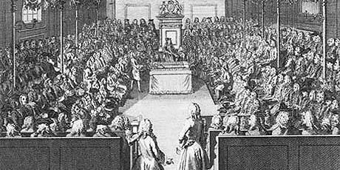
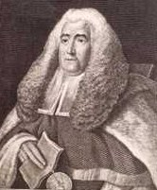
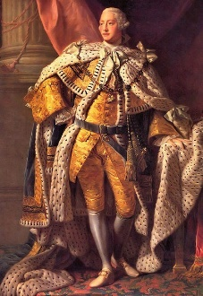
Separate...
← King George III
House of Commons ↓
Sir William Blackstone, an →
18th century English judge
Montesquieu studied the laws, customs, and governments of European countries to see how they created and enforced laws. He admired the government of England.
The English government had three parts: a king to enforce laws, Parliament to create laws, and courts to interpret laws. The government was divided into parts, and each part had its own purpose. Montesquieu called this the separation of powers.

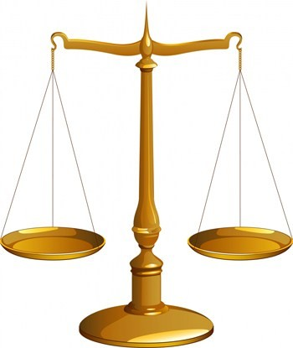

Sound Familiar?
…but Equal
Dividing the powers of government was just the first step. Each part of the government needed to be balanced with the other parts. Montesquieu thought that each of the parts, or branches, of government should be equal. He worried that if one branch had more power than the others, people would suffer and lose their liberty. To avoid this, he suggested that each branch have the ability to limit the power of the other two branches. In England, if the king tried to take too much control, the Parliament or the courts could act to stop him. Today, we call this the system of checks and balances.

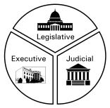
James Madison, the “Father of the Constitution,” liked the idea that each branch of government should have a clear role. As a result, the
U.S. Constitution clearly explains what each branch is supposed to do: Congress makes laws, the President enforces laws, and the Courts interpret laws. Each branch has the power to check, or limit, the other branches. This keeps all branches of government balanced and equal.

Baron de Montesquieu Name:
Roots of Our Government. Use the word bank to fill in the graphic organizers to see the similarities and differences between the US and English governments. (We gave you two to start out.) One word will show up twice!
Senate
Congress
Courts
King
Parliament
House of Lords
House of Commons
President
House of Representatives

England’s
government in the 1800s
Government
created by the
u.s. constitution
House of Lords
Courts

To Serve and Protect. There are many rules out there that are meant to keep you from harm. Think of a rule important to you. Then draw it.
Big Ideas. Each statement below is wrong. Cross out the incorrect parts and correct it on the line.
- Montesquieu’s thinking only influenced people in France.
Rule:
_
_
- Montesquieu thought liberty means people can do whatever they want.
_
_
- Separation of powers happens when everyone follows the law.
_
_
- Montesquieu believed a king should have most of the power.
_
_
- Checks and balances means no branch can limit the power of another branch.
_

